|  |
| --- |
| Photo displaying partial image of two pie charts on a canvas-textured page |
| ME50366  Individual Assignment |
| |  |  |  | | --- | --- | --- | | Sadiq Tijjani | 3/31/23 | Word Count:3054 | |

Emotional Intelligence as a pre-condition for Leadership

The word Leadership is a combination of two concepts, “Leader” from the old English *Laedan* which means “one who leads or one who guides” and “ship” which is a derivative of the old English “*sciepe”* which meant “state or relational condition of being”(Etymonline, 2016), leadership is therefore the point where that act of conducting with all it’s necessary preconditions(i.e. Knowledge and possession there-of) meets the ability to create and sustain relational states of communication, in other words, emotional intelligence. The term emotional intelligence was coined in 1990 by researchers John Mayer and Peter Salovey and was later popularized by the psychologist Daniel Goleman, Lauren Landry(2019) of the *Harvard Business Review* defines emotional intelligence as the ability to understand and regulate one’s emotions as well as acknowledge and influence the emotions of those around you. Daniel Goleman(2004) in his Harvard Business Review article titled *What Makes a Leader* postulates that effective leaders have a high degree of emotional intelligence, IQ and technical skills are not irrelevant but are the entry level requirements for executive positions, that is they are only “threshold capabilities”, he posits that “Without it, a person can have the best training in the world, an incisive, analytical mind, and an endless supply of smart ideas, but he still won’t make a great leader”.

The link between emotional intelligence and the management of engineering projects is one that is often over-looked, we can dig up this relation by thinking about what it is that the engineer does. The engineer in essence is a technician specializing in the production of *technical objects*, the philosopher Gilbert Simondon in his book *Individuation In Light Of Notions Of Form and Information* defines a technical object as an artificial device that *has the ability to* or *has already* concretized towards individuation, meaning that technical objects are machines, composed of several individual components coming together to form a unit, whose trajectory results in an increasing tendency to indivisibility and functional and compatible articulation of the set of elements with which they are made. We can already sense here an idea that approaches the technical objects to the notion of individual found in biology, where-in each individual is constituted of a set of articulated devices that separately form a body, under this interpretation the engineer effectively becomes a maker of *open* objects, that is, objects that have an internal resonance and are aware of all the changes around them, this conclusion is crucial in its opposition of the viewpoint taken for granted that the worlds of the development of technical objects and that of society at large exist independently of one another. Under this Interpretation of the technical object, a car is not just some closed stand-alone apparition of technical development but an artificial object at some stage of its individuation with its constitutive units possessing a social tendency imposing cultural signs to technical objects, in simple terms, the world of engineering intricately and intimately interacts with that of society at large.

Emotional Intelligence now becomes crucial for the engineering and the engineering manager because the ability of engineers to understand their customers’ needs and empathize with the end users are crucial for creating successful, open and internally coherent products and services. Secondly, engineers need people skills for communicating and delivering their tasks as engineering is becoming more and more of a team endeavor(The Global Scholars, 2018). Third, emotionally intelligent engineers have the ability to better appreciate cultural differences and effectively operate within different cultural settings( Sadiku et al, 2020). The engineering project is also analogous to the technical project, in the sense that they both are constituted of individual units coming together to form a coherent whole, a coherent whole that strives towards efficient self regulation, as such the management of the processes of technical development is a task that requires the ability to self-regulate and understand/regulate the relational states(states that involve the communication of either emotional or technical information) of others. Emotional intelligence encompasses four main skills: ***Self-Awareness*** - the ability to know your emotions, strengths, weaknesses, drives, goals and be able realistically assess self-ability and self-confidence, ***Self-Management*** - the ability to stay calm when emotions are running high, ***Social-Awareness*** – the ability to induce desirable responses in others and ***Relationship-Management*** – the ability to understand others, listen well and read nonverbal cues.

In an article titled *The role of Emotional Intelligence for Engineering Managers*, Eveline Vrabie(2020) who is a founder, tech lead and manager in many start-ups in the United Kingdom outlines the role of emotional intelligence in workplace wellbeing. Shortly after joining a previous company, she recalls making a mistake misplacing the signing key of another team’s app, this was a considerable error and had the potential to cause a lot of disruption to the company’s users and a lot of cost to the company itself, she decided to self-regulate and write a post-portem to the workplace SharePoint taking accountability, she was met with encouragement from her colleagues including the CTO; “ Not long after, other teams adopted the use of team vaults for sharing keys, rather than unversioned S3 buckets”. In another section, she recalls another unique experience during a three-month Techstars accelerator programme at the beginning of 2020, according to her it was an “It was an intense social skill training programme, through 100 twenty-minute conversations with a diverse range of mentors from the industry, who offered their feedback on our company and ideas”, she elicits how she had mishandled one of the very first conversations with an angel investor she was very keen to get on board, In her own words: “I was eager to prove that we were doing something worthy, not just financially but with a meaningful social impact, so I became defensive of our ideas. Looking back, I should’ve listened more and talked less. The important bit at that moment was to absorb the feedback, especially the negative one, then filter through only the actionable parts of it”. This demonstrates the importance of this ability to perceive, assess and adjust one’s emotional states as it is crucial in having good one on one’s, stifle conflict before it escalates and getting buy-in from various stakeholders.

Moving past just the anecdotal, there is a considerable amount of research on the link between emotional intelligence and leadership capability, Lisa Gardner and Con Stough examine the relationship between leadership and emotional intelligence in senior level managers(2001), in their research paper they investigate whether the Swinburne University Emotional Intelligence Test(Palmer and Stough, 2001) predicted transformational, transactional and laissez-faire leadership styles measured by a multi-factor leadership questionnaire in 110  
senior level managers, Originally Burns(1978) distinguished between the ***transformational*** leader who is able to motivate his/her followers and promotes dramatic change in individuals, groups and organisations and the ***transactional*** leader who addresses the current needs of subordinates by focusing attention on reward for performance, mutual support and bilateral exchanges. The Swinburne university emotional intelligence test is one that provides a total EI score as well as five factors, namely:- ***emotional recognition and expression*** - ability to recognize and express one's own feelings and emotional states, ***emotions direct cognition*** - the magnitude to which emotions and emotional knowledge factor in decision making and problem solving, ***understanding of external emotions*** – ability to recognize and understand the emotions of others, ***emotional management*** - ability to both self-regulate and manage emotional states in others, ***emotional control*** - how effectively emotional states experienced at work, such as anger, stress, anxiety and frustration, are controlled. The questionnaire that was put together by the researchers was a self-report questionnaire consisting of 45 question points relating to the frequency with which the participant displays a range of leadership behaviours and is measured on a five-point scale (0= not at all, 4 = frequently, if not always) assessing transformational, transactional and *laissez faire* leadership styles. The Questionnaires were sent to 250 high level managers and a total of 110 participants responded to the questionnaire, interestingly the results indicated a high correlation between transformational leadership, the outcomes of good leadership(like effectiveness for example) were all found to correlate significantly with the components of emotional intelligence as well as with total emotional intelligence , this indicates to us that that the ability of a leader to be able to recognize and understand the emotions of others in the workplace, to be able to self-regulate and manage the emotional states of other, to be able to control emotional states in the workplace effectively, to make use of emotional data in decision making and problem solving, and to be able to express their feelings to others, is integral to the effectiveness of any leader or manager, furthermore, although the problem of leadership style is not the driving force behind this essay, research by Sarminah Samad(2012) indicates there is a correlative relation between transformational leadership, innovation and organizational performance.

Pia Lappalainen(2014) has conducted particular research on the predictors of effective leadership in the engineering industry, the study investigates relationships between perceived leader performance and three dimensions of managerial capability: **mathematical–logical intelligence**, **personality**, and **socio-emotional intelligence**. It was done through both self-reports and other-reports where-in the results acquired from the managerial sample were compared to subordinate perceptions as measured through an emotive intelligence other-report and a general managerial competence multi-source appraisal. The sample comprised of 80 managers(superiors) and 354 subordinates operating in seven organizations in the Finnish engineering industries, in the first phase of the study the sample managers were asked to complete a test on mathematical-logical intelligence and in the second phase of the study the subordinates of the sample managers were asked to fill out reports two other reports assessing their superiors. Surprisingly the results did not indicate a significant correlation between logical intelligence and subordinate perception, which would seem to suggest, at-least for this sample batch, that a high level of logical intelligence does not ensure subordinate performance or buy-in. Furthermore, 4 of 14 personality dimensions showed a strong correlation with managerial success as evaluated by subordinates: **concrete perception**, **sociability**, **optimism**, and **inspiration**. The Emotive Communication Scale measurements provided an overall Emotive Communication Scale score that correlated strongly with subordinate perceptions, which indicates predictive value for leadership success through its three subscales/dimensions: **assertion**, **emotional availability**, and **inspiration ability**. This study demonstrates how EI competence predicts unique variance in managerial success beyond that explained by the cornerstones of traditional notions of leadership: personality and mathematical-logical capability. Although the relatively small sample of the study limits the generality of the results , they replicate, support and are in congruence with other such research, for example, Daniel Goleman(2004) in his aforementioned article for Harvard Business Review outlines how he looked into what personal capabilities were the driving force behind outstanding organizational performance and to what degree they did so, he separated capabilities into purely **technical skills(**e.g. accounting), **cognitive skills**(e.g. analytical reasoning) and **emotional intelligence**(e.g. ability to work with others). Analyzing competency models created by interviewing senior managers from 188 companies(including British airways, Credit Suisse etc.) on the capabilities that typified the organization’s most outstanding leaders, Goleman discovered that intellectual competencies and cognitive capabilities(such as big picture thinking and long term thinking) were important but emotional intelligence proved to be doubly as important as the other skills for jobs at all levels after calculating the ratio of technical skills to IQ to EI. The above outlined research efforts all conclusively arrive at the fundamental conclusion that leaders with emotional intelligence capabilities have a positive impact on subordinates and organizational culture.

Self-Reflection on Emotional Intelligence

Using the model below I will endeavor to elucidate my a posteriori thoughts on the importance of emotional intelligence.

Diagram of the Gibbs Model
[1]

Diagram Of The Gibbs Reflective Model

Throughout the Engineering Business Management masters program so far, I’ve been allocated into groups for various assignments and in-class tasks. Particularly, in the group I was allocated into for the Project and Change Management module, we were tasked in each class with discussion based activities to be delivered within relatively short time spans(15 to 45 minutes) and I noticed what tended to happen in the group(consisting of 8 people) was those of the group members who were from relatively similar cultural contexts would discuss more within than little sub-group than with the larger group, for example I found myself talking more with my Indian or east African group members than with the Chinese because , I hypothesize, of a shared cultural and/or historical context, India and the countries Africa are coming off of a relatively long history of colonial pressures, particularly my corner of the continent(Nigeria) being colonized by the British manifests a situation where my experience and that of other Africans and Indians tended to amalgamate to singularity, the socio-political-economic contexts are analogous, we’ve been speaking English all our lives so communication is easier and so the jokes land a bit quicker. The table we were allocated to in the class was one of those long ones with 4 chairs on each side, so I implore the reader to imagine 3-4 people on the front end of the table where the idea generation and discussion tended to happen and 4 people at the back-end of the table scrolling Instagram on their phone or playing games on their laptop, occasionally those at the front end of the table would call out an inquisitional “MARCO” which was often times met with a reluctant/unenthusiastic “POLO” from the back-end of the table, sometimes it would elicit no response at all, working in a group I believe is analogous to a game of marco-polo where-in one sub-section of the group is trying to find the other. I say all this not to set up some paradigm of good and bad between the two ends of the table but to raise the question of what could be the cause of this curios state of affairs.

I tend to feel a little indifferent about these things after-all it’s just a group activity, the coursework probably doesn’t have a lot of correspondence with what actually goes on in the real world, I’ll probably forget most of it 3 months after the degree program ends and I’ll probably do this one thing and never see the group members in my life ever again, in fact, I had two different groups in the final year of my computer engineering degree where lines of communication broke down and I decided to do the projects either entirely myself or with one other person, after one of the projects had been turned in a group member, presumably because he felt some sort of guilt, messaged me a paragraph explaining the personal reasons why he didn’t contribute a single line of code and expressing some thanks he felt like he owed me, to which I replied a resounding “no problem, bro”, I tend to think life isn’t that serious, I could do all that work and then go outside and get hit by a bus. This time I actively tried to engage with and involve those at the back-end of the table , I’d told them it didn’t matter how good they were with English just say what you think and we’ll figure it out, when we felt they had a good idea we would put them in the hotseat when the teacher asked from thoughts from our group by handing the mic to them, we even tried switching seat positions. A couple of weeks in we did a 360-peer evaluation and I received feedback from the group saying I was domineering and pushy, this didn’t cause any feelings of anger or frustration, it just became clear to me that something was being lost in translation.

What was markedly positive about our group was that I believe we never developed a dislike for one another, in fact I remain very friendly with 7 out of the 8 people in that group, what didn’t work well for us was for the reasons mentioned above we were bad at time management and task coordination, every activity was like waiting for the last boarding call before boarding onto your flight, the variety of communication styles across cultures in our group also didn’t help, when someone had a not so good idea an awkward silence would reign until someone did the classic “Or…..”, come to think of it I do not recall someone from the frontend of the table explaining why another person’s Idea wouldn’t work.

I think the primary reason why we couldn’t work smoothly was because we never stopped to ask each other what communication styles worked best for us, how do we motivate one another? , what particular things were we individually good at? And most importantly what did we ***feel*** about certain situations, what did you feel about the last activity? Did you feel your opinions were given appropriate consideration? What can each of us do to improve? ***Do you maybe want to go have lunch together after this?*** , basic elements of emotional intelligence none of us ,I must say, were brave enough to put to question, indeed, the attributes that indicate healthy interpersonal EI in a team according to Vanessa Druskat and Steven Wolff in their article *Building the Emotional Intelligence of Groups****,*** are: trust among members, a sense of group identity, and a sense of group efficacy. Can a team function without these conditions? Of course. Will the team reach its ultimate potential and realize it’s work as efficiently as possible? Most likely not, in the penultimate class we received feedback from the teacher saying we were one of the top performing groups in the class to which we all burst into laughter to the complete puzzlement of the teacher because we knew the internal mechanisms of the group. Teachers when given the chance will try as much as possible to reduce the task of working in a group to a mere formality, it is not, especially in more diverse groups where one’s “MARCO” has to be resilient enough to extend half-way across the world for it’s corresponding “POLO”.

In the future I want to be able to get the gears of which-ever groups I find myself in running efficiently quicker and more sustainably by developing the skill(and courage) to apply and ***get my group members*** to apply principles of emotional intelligence. Using the personal development plan below I will endeavor to get better at particular facets of Emotional Intelligence.

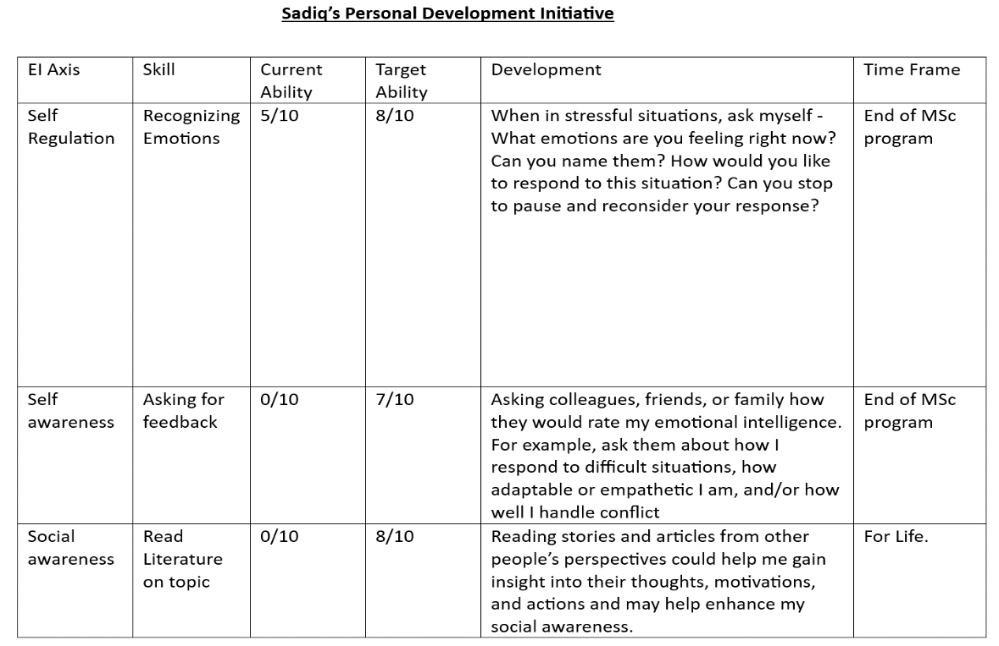

Snapshot Of Personal Development Plan

# References

Etymonline., 2016. *Leadership.*[Online]Available at: <https://www.etymonline.com/word/leadership#etymonline_v_30153> [Accessed 7 March 2023]

Landry, L., 2019. *Why Emotional Intelligence Is Important In Leadership.* [Online] Available at: <https://online.hbs.edu/blog/post/emotional-intelligence-in-leadership> [Accessed 8 March 2023]

Goleman, D., 2004. *What Makes A Leader?.* [Online] Available at: <https://hbr.org/2004/01/what-makes-a-leader> [Accessed 8 March 2023]

Simondon, G., Translated by Taylor Adkins, 2020. *Individuation In Light Of Notions Of Form And Information.* Minneapolis, University Of Minnesota Press, [Online] Available at: <https://www.upress.umn.edu/book-division/books/individuation-in-light-of-notions-of-form-and> [Accessed 10 March 2023]

Al-Atabi, M., 2018. *The Importance Of Emotional Intelligence In Engineering.* [Online] Available at: <https://theglobalscholars.com/the-importance-of-emotional-intelligence-in-engineering/> [Accessed 10 March 2023]

Sadiku, M., Olaleye, O., Musa, S., Perry, R and Jordan-Mickey, B., 2020. *Emotional Intelligence In Engineering.* International Journal of Trend in Research and Development[Online] , 7(2). Available at: <http://www.ijtrd.com/papers/IJTRD22017.pdf> [Accessed 10 March 2023]

Varbie, E., 2020. *The Role Of Emotional Intelligence for Engineering Managers.* [Online] Available at: <https://medium.com/jump-start/diversity-inclusion-and-managing-conflict-as-an-engineering-manager-758a857a01e> [Accessed 14 March 2023]

Gardner, L. and Stough, C. 2002. *Examining the relationship between leadership and emotional intelligence in senior level managers,* Leadership & Organization Development Journal[Online], 23(2). Available at: <https://doi.org/10.1108/01437730210419198> [Accessed 15 March 2023]

Palmer, B. and Stough, C., 2001. *Workplace SUEIT: Swinburne University Emotional Intelligence Test – Descriptive Report,* Organisational Psychology Research Unit, Swinburne University, AU. [Accessed 15 March 2023]

Burns, J. (1978). Leadership. Harper & Row, [Online] Available at: <https://archive.org/details/leadership1978burn> [Accessed 16 March 2023]

Sarminah, S., 2012. *The Influence of Innovation and Transformational Leadership on Organizational Performance*, Procedia - Social and Behavioral Sciences[Online], Volume 57. Available at: <https://doi.org/10.1016/j.sbspro.2012.09.1215>. [Accessed 16 March 2023]

Lappalainen , P., 2015*. Predictors of effective leadership in industry – should engineering education focus on traditional intelligence, personality, or emotional intelligence?*. European Journal of Engineering Education[Online], 40(2). Available at: [10.1080/03043797.2014.944102](https://doi-org.ezproxy1.bath.ac.uk/10.1080/03043797.2014.944102) [Accessed 19 March 2023]

Druskat, V. and Wolff, S., 2001. *Building The Emotional Intelligence of Groups.* [Online] Available at: <https://hbr.org/2001/03/building-the-emotional-intelligence-of-groups> [Accessed 20 March 2023]

Gibbs, G. (1998) Learning by Doing: A Guide to Teaching and Learning Methods. Oxford Brooks University, Oxford.

1. Image gotten from : <https://www.ed.ac.uk/reflection/reflectors-toolkit/reflecting-on-experience/gibbs-reflective-cycle>